Robot war

*Object-Oriented Analysis and Design*

*Tutor : Ian Chai*

|  |  |  |
| --- | --- | --- |
| Name | Phone Number | Email |
| Wong Tiong Kiat | 0122321133 | [jackwongtiongkiat@gmail.com](mailto:jackwongtiongkiat@gmail.com) |
| Choe Choon Ho | 0125388203 | [choechoonho@gmail.com](mailto:choechoonho@gmail.com) |
| Ng Chen Hon | 0173029988 | [ngchenhon@gmail.com](mailto:ngchenhon@gmail.com) |
| Lim Yun Shen | 0126801693 | yunshenlim1996@hotmail.com |

TAble of  
Contents

INSTRUCTION 1

USER GUIDE 2

use case diagram 3

class diagram 5

sequence diagram 6

Instruction

### 1. Download Eclipse

### 2. Use command line:

### 3. Type the following:

java -cp startup.jar -noSplash -data "D:\Source\Project\workspace" -application org.eclipse.jdt.apt.core.aptBuild

* Project is built using Eclipse

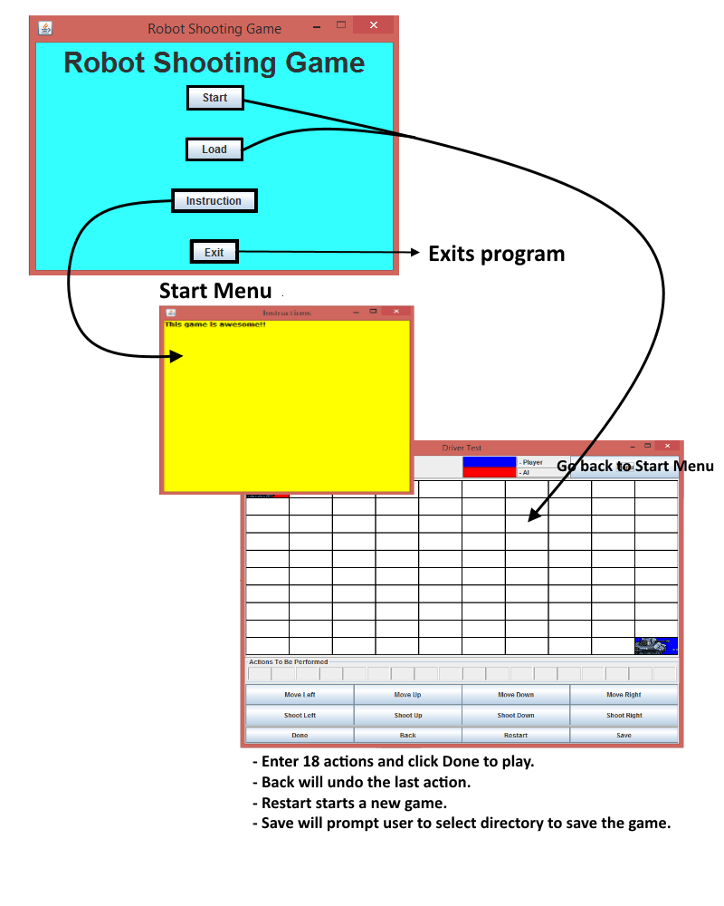User Guide

USE case Diagram

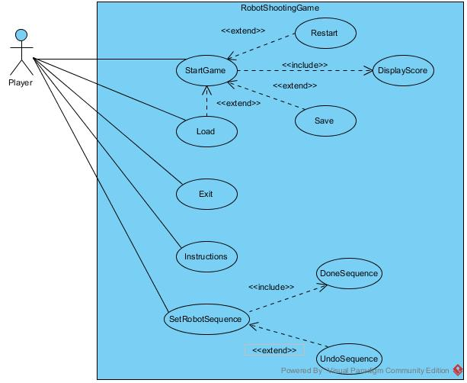

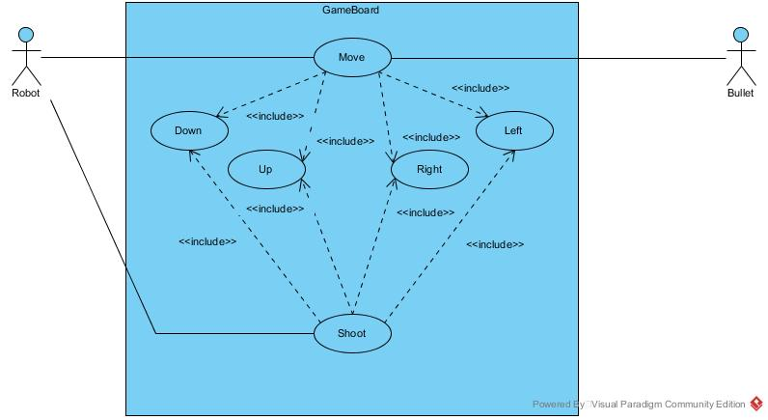

Class diagram

Please refer to the file in same directory as this report, we cannot fit the UML class diagram into the document as it’s too big.

Sequence diagram

